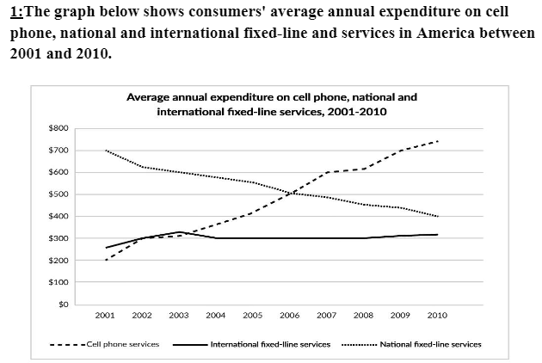

**Dàn bài**

**Overview:**

Cell phone services + international fixed-line services increased → national gradually fell

Cell phone services → strikingly upward trend → largest point in the end.

**Body 1: 2001 → 2006**

+ 2001: highest:national fixed-line >< lowest: cell phone services

+ after 5 years: cell phone → incredibly increased ( 500 ) = national

International → slowly rose to around 320→ fell and remained at 300

**Body 2: 2006 → 2010**

Cell phone continuously rose → reached the peak of 750 in 2010 >< national fixed-line services → gradually fell to 400

International fixed-line → stayed unchanged → smallest

Given is the graph illustrating Americans’ spending on cell phone, national and international fixed-line services from 2001 to 2010.

Overall, the expenditure on Mobile phone services and International fixed-line services increased, while the figure for National fixed-line services fell. It is clear that for cell phone services experienced a strikingly upward trend and finally reached the highest point in the end of the period.

In 2001, the expenditure on National fixed-line services accounted for the biggest point, at 700 dollars. On the contrary, the figures for both International fixed-line services and Cell phone services were much lower, only at 250 dollars and 200 dollars in the order given. After 5 years, a incredible growth can be seen for the spending on Cell phone services, at 500 dollars, which was as equal as that on National fixed-line services in the same year.

From 2006 to 2010, the number of Cell phone services continuously rose and reached the peak of 750 while the money used for National fixed-line services gradually fell to 400 in 2010. Besides, the figure for International fixed-line services oscillated around 320 dollars from 2001 to 2004 and then stayed unchanged at 300 dollars up until 2010. (198 words )

* + Overall:
    - While the yearly spending on mobile phones increased significantly, the opposite was true for national landline phone expenditure. >> IELTS TUTOR hướng dẫn [Cách dùng động từ "spend" tiếng anh](https://www.ieltsdanang.vn/blog/cach-dung-dong-tu-spend-tieng-anh)
    - The figure for international fixed-line service was lowest among three kinds over the period shown.
  + Body 1:
    - In 2001
      * There was an average of nearly $700 spent on national landline phone services by US residents, in comparison with only around $200 a piece on mobile phone and international landline services (nêu số liệu)
    - Over the next five years (2005)
      * The average amount spent on national fixed-line phone services fell substantially by approximately $200.
      * Yearly spending on cell phone services witnessed a significant increase of roughly $300.
      * The figure for overseas landline services remained stable at $300.
  + Body 2:
    - In 2006
      * US consumers spent the same amount of money on mobile and national fixed-line services, with just over $500 on each. >> IELTS TUTOR hướng dẫn [Cách dùng danh từ "spending" tiếng anh](https://www.ieltsdanang.vn/blog/cach-dung-danh-tu-spending-tieng-anh)
    - From the year 2006 onwards
      * The average yearly expenditure on mobile phones surpassed that on national fixed-line phones and mobile phones became the most common means of communication (nêu số liệu) ([IELTS TUTOR](https://www.ieltstutor.me/blog/sua-de-thi-ielts-writing-22-8-2020) gợi ý cách diễn đạt khác: Yearly spending on mobile phone services increased to nearly $750 in the last year while the figure for national landline phone ones decreased to about $400 at the end of the period)
      * There was a stability in the figure for overseas phone calls. >> IELTS TUTOR hướng dẫn [Paraphrase về "thu nhập"(income) & "chi tiêu"(expenditure](https://www.suabaiieltswriting.com/blog/paraphrase-thu-nhap-chi-tieu)
  + IELTS TUTOR lưu ý:
    - Bài này nếu chia 2 đoạn thân bài theo đối tượng thì có thể sẽ viết thiếu chữ nên sẽ chia theo thời gian nhé